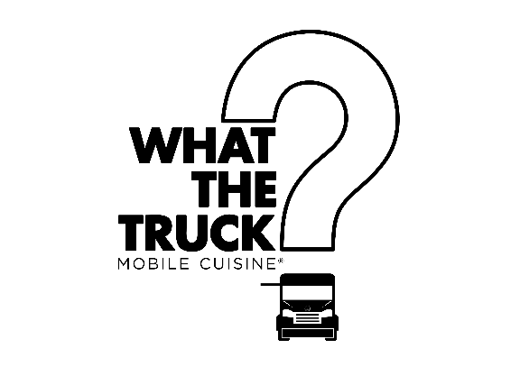

What The Truck? is a US-styled food truck based in Manchester. We aim to provide quality street-food on and off the streets and we’re taking over @theoldkingsarmspub for the next few weeks!

Don’t forget to check in & tag us in your photos ! **@whatthetruckmc**

We create/develop all of our products, so if you have any allergies or intolerances, just speak to a member of staff for further info.

  

**Mac + Cheese**

Cheese-lovers heaven.

Gooey mozzarella, cheddar & red leicester macaroni with black onion seed topping & red pepper ketchup

**Buffalo Wings**

Who said chickens can’t fly?

Crispy chicken wings glazed with a honey barbecue buffalo sauce with sour cream and house slaw

**Calamari**

Surf & turf.

Pork-crackling dusted squid pieces with smoked garlic aioli and house slaw

**Truffled Fries**

Our signature.

Skin-on French fries with truffle, parmesan, black pepper & smoked garlic aioli

**Naked Fries**

Lightly seasoned, skin-on French fries with smoked garlic aioli

**Philly Cheese-Steak**

Meat meets cheese.

Shaved rib-eye steak, caramelised green peppers & onions, Monterey Jack cheddar, pickled gherkins, red pepper ketchup and crispy onions on a “hoagie” bread roll.

**Lamb Slammer**

A feast from the middle-east.

48-hour slow-cooked lamb shoulder, red onion & chickpea falafel, house slaw and lemony sour cream in a toasted tortilla wrap

**Fish Wrapper**

She sells sea shells. We don’t.

Crispy, deep-fried fillets of coley, house slaw, smoked garlic aioli, sriracha hot sauce and fresh guacamole in a toasted tortilla wrap

**Trucky Fried Chicken**

Finger lickin’ better than that colonel.

Coated buttermilk chicken thigh, Monterey Jack cheddar, smoked bacon, house slaw, smoked garlic aioli and red pepper ketchup on a brioche bun

**Chilloumi Bowl**

Makes you wanna go veggie.

A load of our vegetarian chilli (non-carne), fried halloumi, fresh guacamole and sour cream in a crispy tortilla bowl

***All main items served with Naked Fries. Upgrade to Truffled Fries for an extra £1.50***

-----------------------------------------------------------------------

**PB + J**

American classic – for a reason.

Peanut Butter Parfait, fluffy doughnut ring and plum jam

**Mississippi Mud Chimichanga**

Get down and dirty with this.

Deep-fried chocolate & banana chimichanga, chocolate soil and vanilla ice-cream